Create a Employee Collection add 5 documents:

Example:

{empno:111,ename:”Deepali

Vaidya”,sal:40000.00,dept:{deptno12,dname:,”Hr”,dloc:”Mumbai},

Desg:”Analyst”,mgr:{name:”Satish”,num:111},project:[{name:”Project-

1”,Hrs:4},{name:”project- 2”,Hrs:4}]}



1. All Employee’s with the desg as ‘CLERK’ are now called as (AO) Administrative Officers.

Update the Employee collection for this.



2. Change the number of hours for project-1 to 5 for all employees with designation analyst.

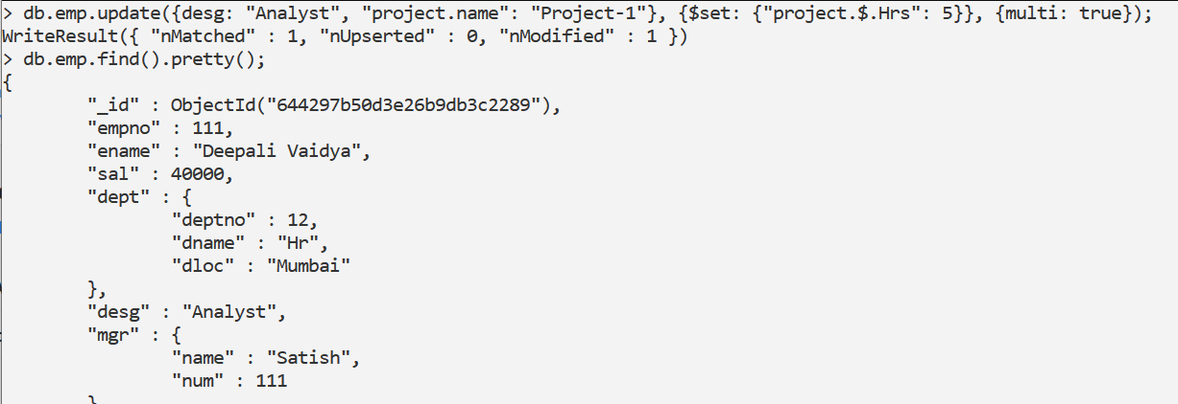

3. Add 2 projects project-3 and project-4 for employee whose name starts with ”Deep” with 2 hrs

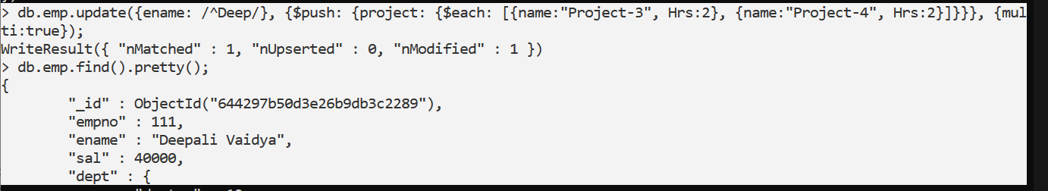

1. Add bonus rs 2000 for all employees with salary > 50000





1. Add bonus rs 1500 if salary <50000 and > 30000



1. increment bounus by 1000 for all employees if salary <=30000



7. Change manager name to Tushar for all employees whose manager is currently “satish”

And manager number to 3333



8. Increase salary of all employees from “purchase department” by 15000



9. Decrease number of hrs by 2 for all employees who are working on project-2

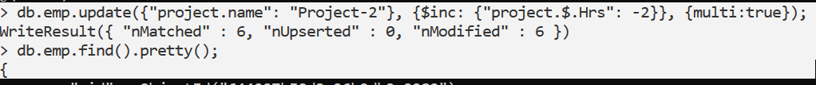

10. Delete project-2 from all employee document if they are working on the project for 4 hrs.



\*\*\*\*above query updated my empno115 object to only one field project.hrs present in that.



11. Change the salary of employees to 10000 only if their salary is < 10000



12. Increase bonus of all employees by 500 if the bonus is <2000 or their salary is <

20000 or if employee belong to sales department

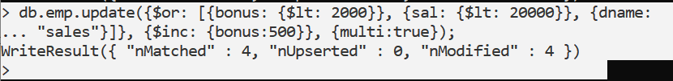

13. Add 2 new project at position 2 for all employees with designation analyst or salary is equal to either 30000 or 33000 or 35000



14. Delete last project of all employees with department name is “HR” and if the location is Mumbai



15. Change designation of all employees to senior programmer if they are working on

name:”Project-1” for 4 hrs

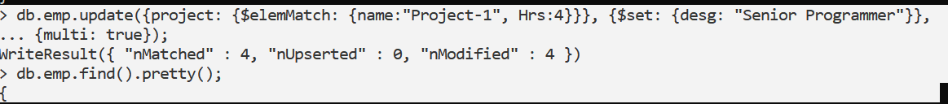

1. Add list of hobbies in all employees document whose manager is Rajan or Revati

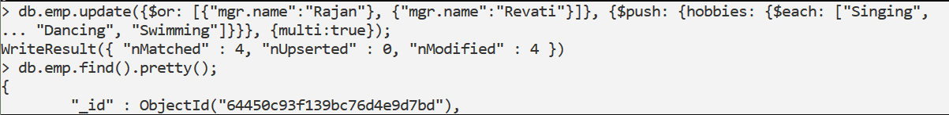

17. Add list of skillset in all employee documents who are working on project-4 for 3 hrs or on project-3 for 4 hrs

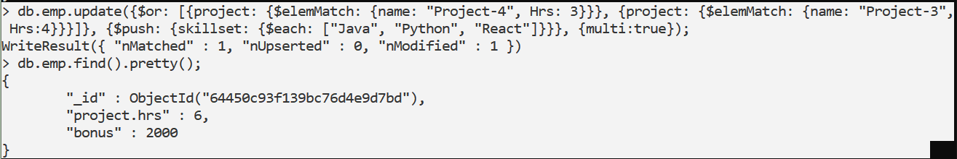

18. Add a new hobby as blogging at 3 position in hobbies array for all employess whose name starts with R or p and ends with j or s

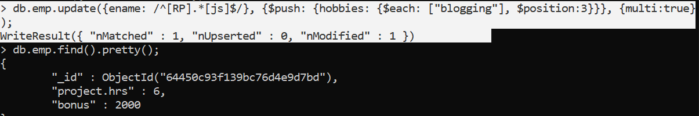

19. Increase salary by 10000 for all employees who are working on project-2 or project-3 or project-1 Decrease bonus by 1000 rs And increase salary by 1000rs for all employees whose department location is Mumbai

db.emp.update({$or: [ {{$or: [{"project.name": "Project-1"}, {"project.name": "Project-2"}, {"project.name": "Project-3"}]},{$inc: {sal: 10000}}}, {{"dept.dloc": "Mumbai"},{$inc: {sal: 1000, bonus: -1000}}}]}, {multi: true});